MD. AWAL HOSSAIN

Contact

**Address:**

Gulshan,Notun bajar Sarkar bari, Dhaka 12-12

**Phone:**

+88 01998201508

**Email:**

Ajmirajking426@gmail.com

**LinkedIn:**

linkedin.com/awal.miraj

Languages

**Bangla:** Excellent in reading,writting and speaking as native language.

**English:** High reading,good writing and medium speaking also .

Hobbies

Writing

Sketching

Photography

Playing

Reading Newspaper

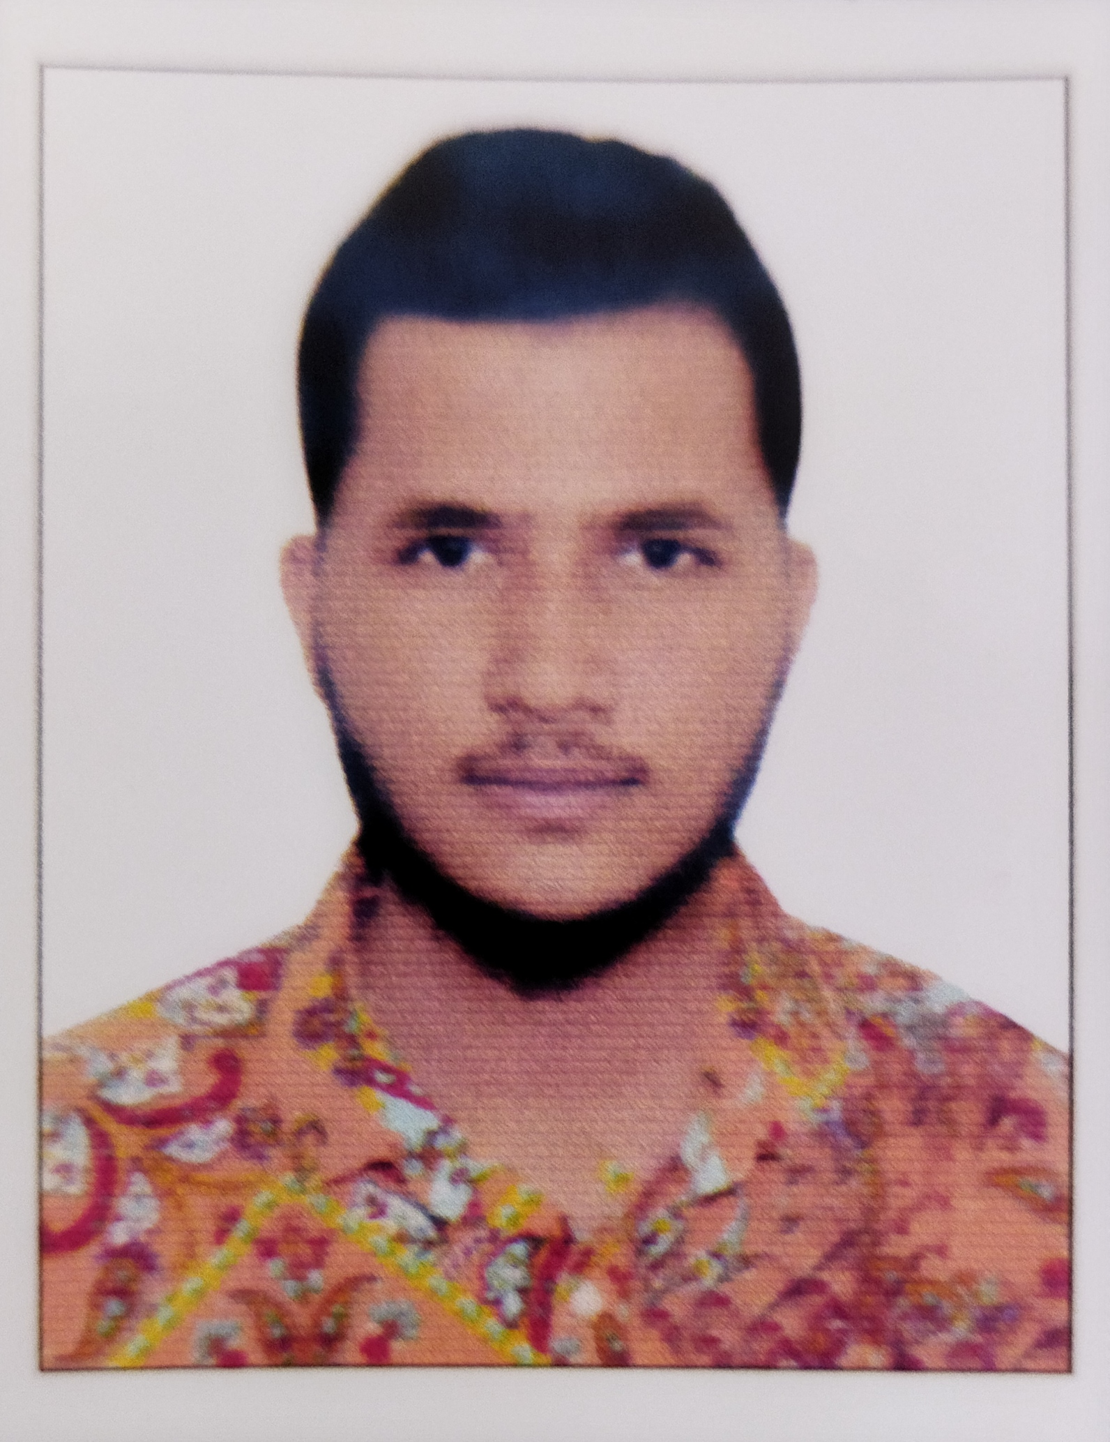

Summary

To prove myself as an excellent professional in the company which provide dynamic and challenging opportunities for personal developments and to contribute towards both corporate and personal growth.

Skill Highlights

|  |  |
| --- | --- |
| * Microsoft Word * Microsoft Excel * Microsoft Access * Internet Browsing   **STRENGTH :**   * Self-confident. * Hard working. * A modest congenial and sociable person. * Ability to work in Groups. * Willingness to accept directions. * Fast to learn new things from others. |  |

Experience

**Happy Wallet**, Bangladesh

* Worked more than 12+ hours a day.
* Handled clients gently and collection increased 50% more than previous.
* Work with seniors to manage large projects for clients.
* Earned a highly ranked profile in collection section in a few months.

Education

**DIPLOMA IN COMPUTER SCIENCE:**

Institute: Rajdhani Polytechnic & Textile College,

Board: Dhaka

Result- Present

**SECONDARY SCHOOL CERTIFICATE: (S.S.C}**

Result- GPA – (4.06)

Background – Humanities

From, Solmaid High School

Under the board of Dhaka

Passing Year - 2017.